**Rossmann Sales Forecasting**

**Abstract**

Rossmann Stores Sales Forecasting is originated from one of Kaggle’s Machine Learning competitions. The task is to predict 6 weeks of daily sales for 1,115 Rossmann stores that are located across whole Germany. In this paper, we will describe how to use existing data set and external dataset in training a forecasting machine learning model for this.

**Project Overview**

Sales forecasting or future prediction base on time series [1] dataset is common in many business cases. The better predictions can make business more efficient in early planning like stock preparation and human power relocation etc. This project is focusing on predicting a chain medicine beauty store called Rossmann daily sales for up to 6 weeks in advanced. Rossmann stores locate across multiple states in Germany. In this task, it proves 1,115 stores properties data and daily sales record from 2013 to 2015. It turns out that predicting numeric continuous data is a regression [2] task in machine learning area, and also this is a supervised learning [3]. Regression Analysis is to focus on the relationship between dependent variable and one or more independent variables. In machine learning area, there are many regression algorithms that we can use for this purpose, linear regression[4], SVM regression[5] and Decision Tree[6], all of which have their pros and cons.

**Project Statement**

In this project, predicting daily sales for up to 6 weeks in advanced is a supervised regression problem. By using machine learning models to predict the sales numbers from a set of vary dependent features. The targets that need to be predicted is in test.csv dataset. Ultimately, the task is about data analysis and data prediction.

A regression problem need to be justified in performance, we need some metric methods for evaluating our models performance. For general regression problems, we have several evaluation metrics for those. Like Mean Absolute Error [7], Mean Squared Error [8] and R2 squared [9] etc. In this Kaggle competition, we use Root Mean Square Percentage Error (RMSPE) [10]. In this project our goal is to minimize the RMSPE score as lower as possible. Bench mark score will be top 300 in this Kaggle competition.

I will follow data analysis process to apply in this project, which contains data exploratory, data cleaning, feature engineering, Algorithm selection, and model fine tuning. In data exploratory stage, I will load the existing data into Python Pandas data structure , and apply some data exploratory function to take a look at the data first, and then I will clean the data as needed, since good predicting model comes from good data. After all these, I will try to use find out the relationship and coefficient relationship among the dataset, and apply feature engineering on this, also the most important step in this project. Then I will apply the selected features to candidate algorithm and compare their performance by metrics. The expectation for this project is the performance metrics as low as 0.117, of course the lower the better. Meaning your prediction is closer to the true value.

**Metric**

In this project, we will use Root Mean Square Percentage Error (RMSPE) for evaluating the model performance. RMSPE is suitable for evaluating regression problem. Basically, it will calculate how close the perdition value to actual value by putting punishment (scale) on large error. Our model will use SGD [11] method to decrease the value of RMSPE, the perfect situation would be 0 as no errors at all. Here with the formula for RMSPE:

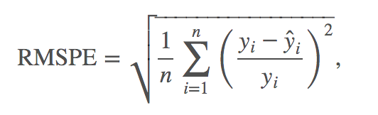

Where y_i is the actual target value for a record, in this project, it will be the sales of a single store on a single day and y_hat is the predict target value.

**Analysis**

**Data Exploration**

In this project, it provides several datasets for competition purpose, and you are also allow to use external dataset as you can post the source where it comes from. I will first try to use the available dataset. There are three available datasets in the project: train.csv, store.csv and test.csv. Train.csv and store.csv are the training data for building the model to predict the targets in test.csv. Train.csv records 1,017,209 rows of different stores daily sales records from 2013/01/01 to 2015/07/31 including numbers of customers, store status and days property as state holidays or school holiday. We find that the data in train dataset is complete without missing data. Looking into the dataset, we find 9 features, amount them, Store, DayOfWeek, Open, Promo, StateHoliday and SchoolHoliday are category data, the rest I will treat them as numeric data. Sales is the one we are going to predict, so I will label the Sales as target for training in the later process.

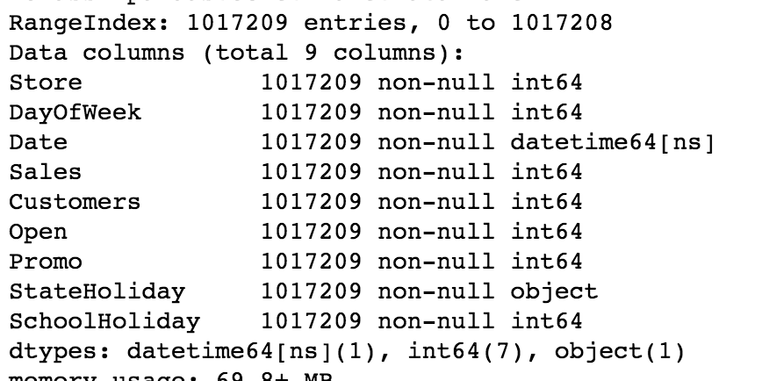

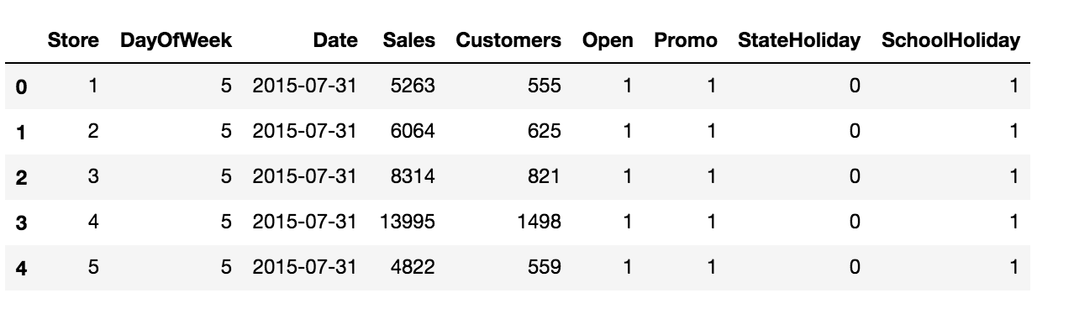

In store.csv, it records 1,115 stores properties value which contains store ID, store type, assortment type, competition information from distance to time beginning, promotion activities information. We can find that there are some missing records in this dataset, for some of reasons like absent or non-applicable, which we will handle this later. Amount them, Store, StoreType, Assortment, CompetitionOpenSinceMonth, CompetitionOpenSinceYear, Promo2 Promo2SinceWeek, Promo2SinceYear, PromoInterval, are category date, other are numeric data.

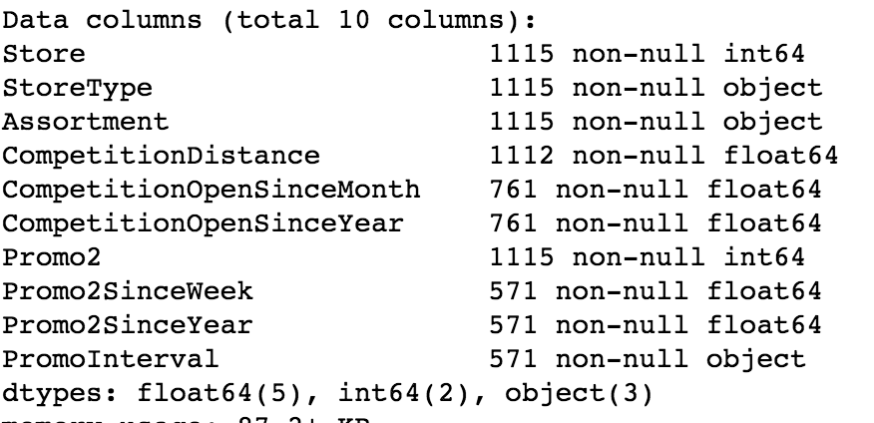

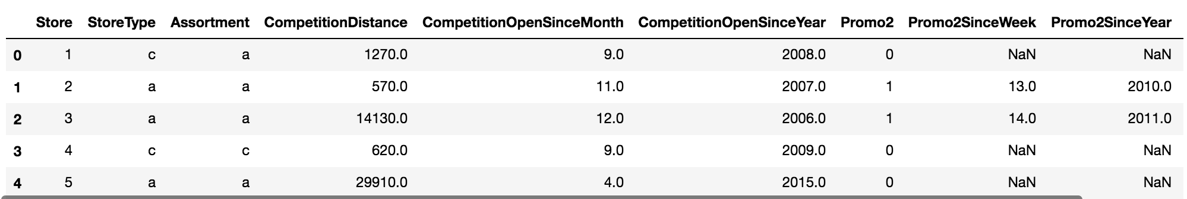

For StoreType, Assorment and PromoInterval, they are represented by character. Value in character is difficult for machine learning model to recognize or even know the importance. So we need to do some preprocessing at later step.

In test.csv, it has 41,088 records that about 1,115 store daily record except sales and customers. There are 11 missing data, we will also need to fix this at later step.

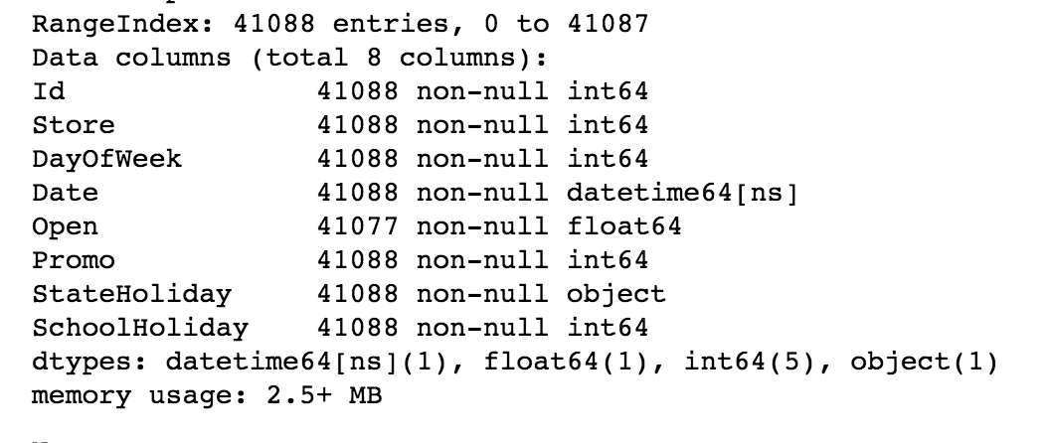

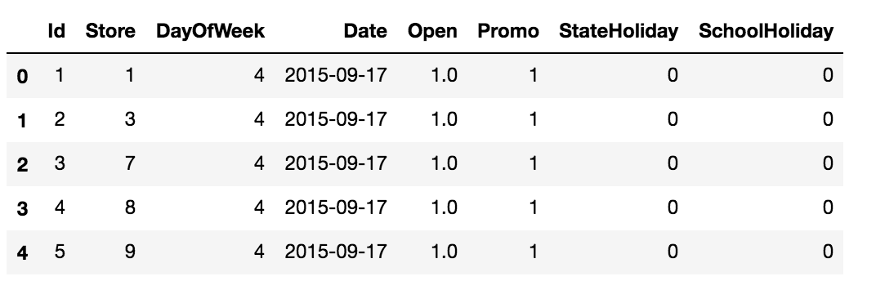

**Exploratory Visualization**

First, I will take a look at the target distribution.

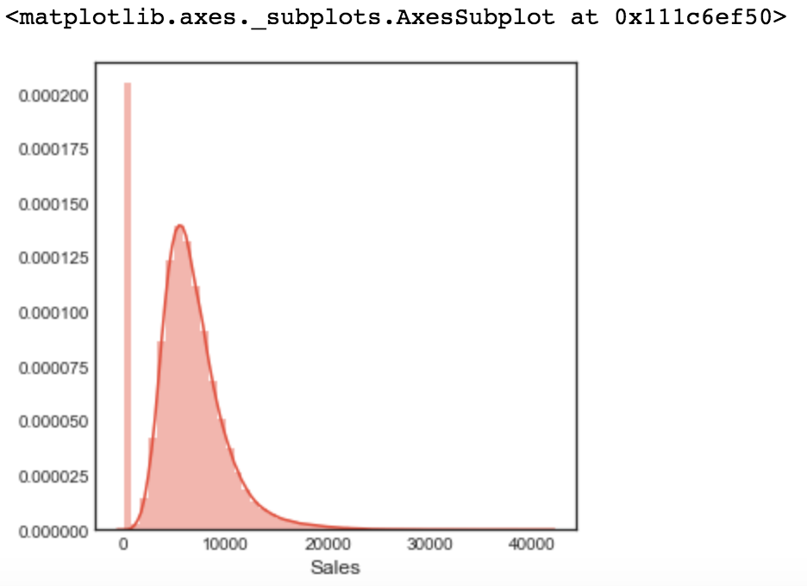

Without data preprocessing, the Sales data has a high skew, high percentage in 0 Sales data, which we need to verify later.

Next, I will check the correlation within dataset. From the diagram below we can see that, Sales have strong relationship with customers, which is true in fact, the more customers the more sales could be.

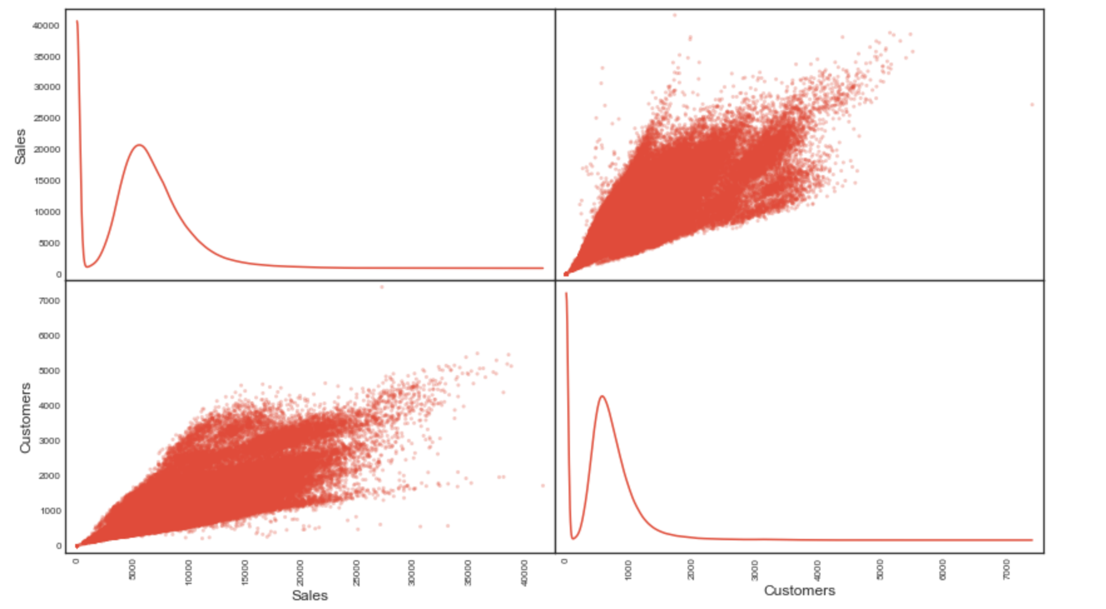

Next, I will take a look at the distribution of different category data. From the diagram, we can interpret that there are few holidays a year, most of the store do promotion, and most of them are open.

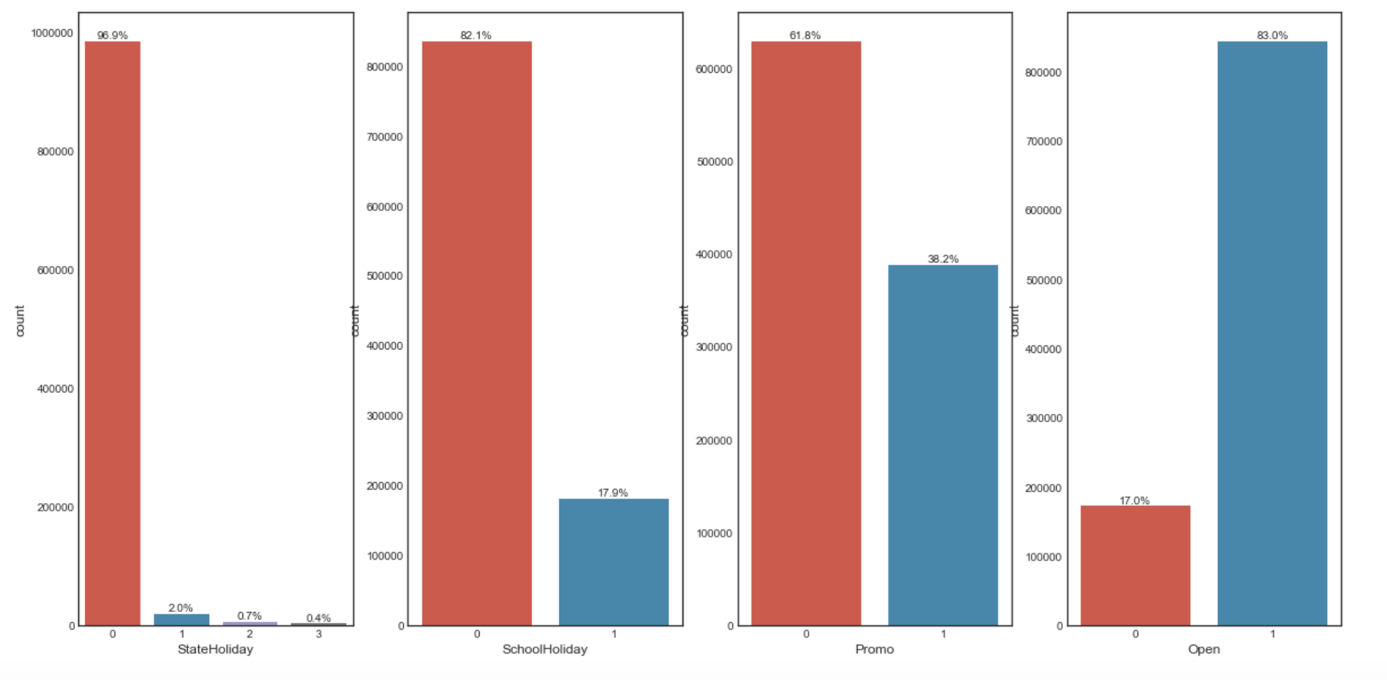

And then I will combine train and store dataset to reveal some relationship between sales and store properties. There are missing value in Competition properties and Promo2 properties due unavailable or purely missing, which we will find out and handle later.

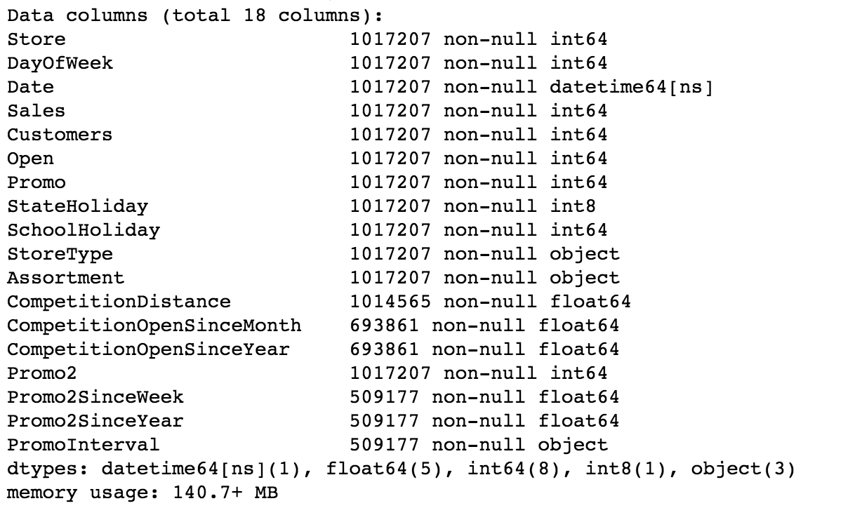

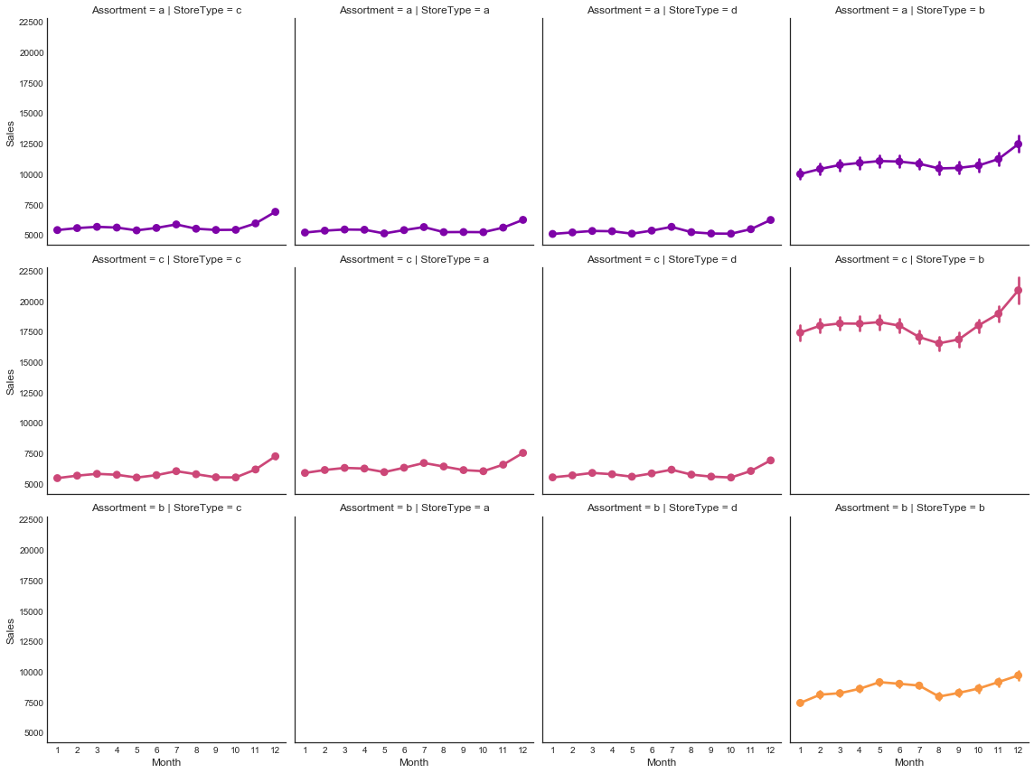

The diagram above shows the relationship amount Sales, StoreType and Assortment, we can find that StoreType b is big different from the others. StoreType b and Assortment c have more Sales than others. The sales trends are similar from those different types of store, which are strong related to datetime.

Next, I will check the relationship about Promo and Promo2, to see how importance they are for predicting the sales.

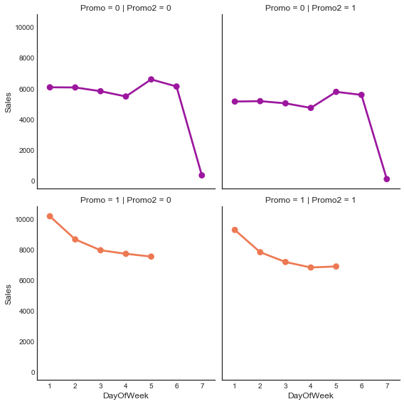

From the diagram above we can find that, Promo is more important then Promo2, and the fact that Saturday and Sunday will have no Promo. And continuous promo (Promo2) make sales lower.

Let’s take a look at the time related diagram. The below diagram shows us the sales in 12 months from different type of stores. We can find out that Store Type B is still higher sales then others. The other types of Store have similar sales pattern. And Sales are varying from different months and days. Except Type B store, other stores doesn’t open on Sunday, so they have similar seasoning pattern in sales.

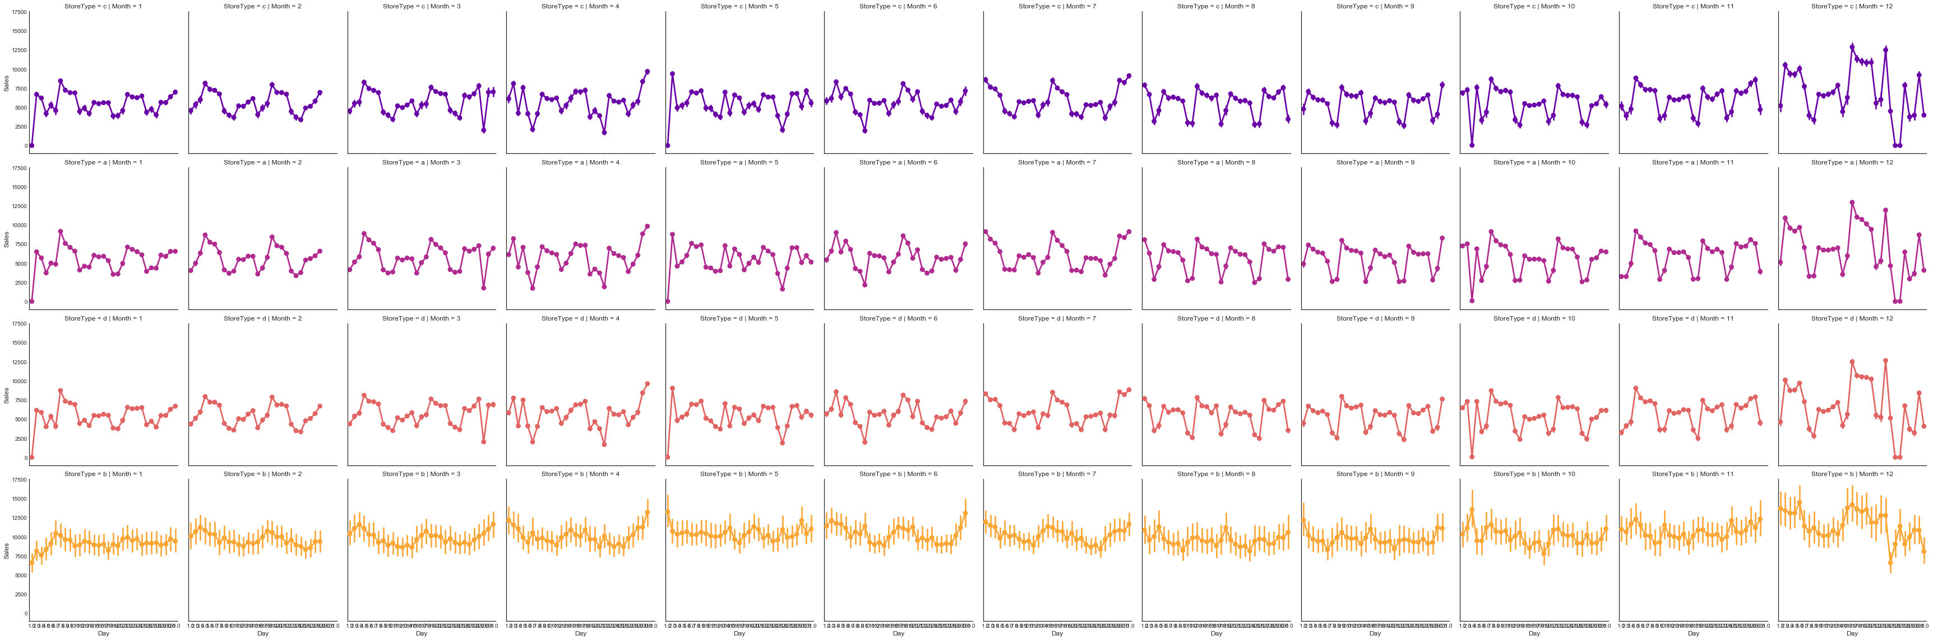

Conclusion:

* There are 4 types of stores and 3 types of assortments; Store of Type B and assortment c is the most selling store and open on Sunday. The other type of stores will close at Sunday.
* Daily Sales have strong coefficient with Daily Customers.
* Promo2 (Continue promotion) has no benefit to increase Sales
* Store type in a,b,c share the same pattern in sales, varying from months to months, days by days.

**Algorithms and Techniques**

In this project, I apply XGBoost, a scalable end-to-end tree boosting system to train the prediction model. Since XGBoost has been proven in many machine learning challenge to achieve state-of-art result. Even for this project, training sample size is more than 100k, scalable system can have higher capability in learning from a large dataset.

XGBoost is advanced from Tree Ensemble methodology, by assembling multiple simple decision trees model to generate a better result. The tree ensemble model is a set of classification and regression trees (CART) [12]

The advantage of decision tree is that it’s adaptable to different kind of data type from numerical to categorical data. Tree process and algorithm can be easily interpreted, and also suitable for nonlinear regression problem. The disadvantage of tree is that it’s easily be overfitting, and complexity can will take a long time for training.

XGBoost refine algorithms, and find a balance between variance and bias. Below is the objective function from XGBoost. L(θ) is the loss function for judging how close the prediction is to the actual value. For regression problem, MSE is normally used in loss function. Actually, XGBoost is suitable for custom loss function, so it’s more flexible in model training.

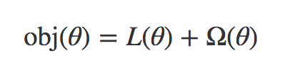

Considering the regularization terms Ω(θ) will control the complexity of the model, which will lower the chance of overfitting.

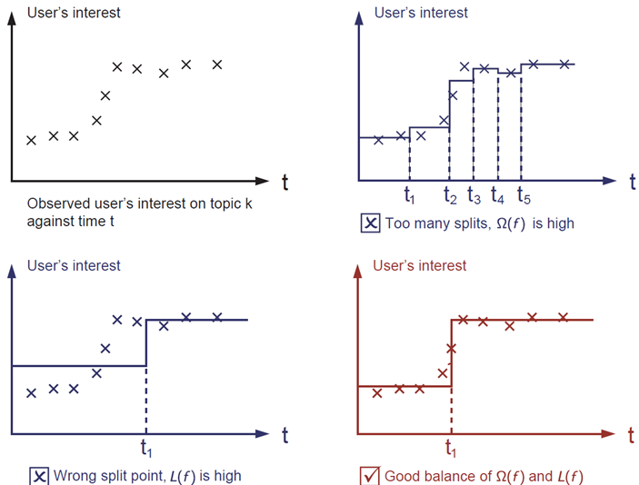

Finally, we need to find out the smallest obj(θ) for the best model.

XGBoost has three types of parameters for above purpose: General Parameters, Booster Parameters and Learning Task Parameters [13]. In this task, we will try to find out the features that best suit to the tree algorithm and tuning the algorithm parameters to make the good prediction model.

In features selection, I will use xgboost build-in get_fscore function for features importance scoring. And since xgboost has evaluation build-in, I will start with few trees to testify importance features, then get into more depth and vast tree models. The whole process is to balance between complexity and generalization.

**Benchmark**

In the Rossmann competition from Kaggle, the top 330 competitors can reach a score as low as 0.117 in leader board.

So I expect my result will be lower than 0.117 in terms of two points:

* Bias: the ideal model should have public score as low as under 0.117
* Variance: the ideal model should have private score as low as under 0.117 and have close score to public score, meaning that the model is less overffing to the traning dataset.

**Methodology**

**Data Preprocessing**

Data cleaning and feature engineering takes up most of time in the whole project. The importance of data preprocessing is out weight than other process, since good data generate good model.

1. Data Cleaning

As I mentioned before that, we found some missing data in data exploration section.



CompetitionDistance and other two Competition related data have some Nan value, and Promo2 related properties also have some missing value. I will fill this nan value with 0 and ‘n’ first as symbol. Since XGBoost is also good at handling missing value.

Most of the data type are good to go with, so next I will do the feature engineering.

1. Feature Engineering

In this part, I will try to transform some features for training.

1. Data Transformation

I pick some feature with large scale in date range like competition distance, sales, customers to transform to lower scale by using logarithm.

Then I transform categorical data to numeric data by Label Encoding, since XGBoost is not capable of dealing with categorical data. They are StateHoliday, StoreType, Assortment .

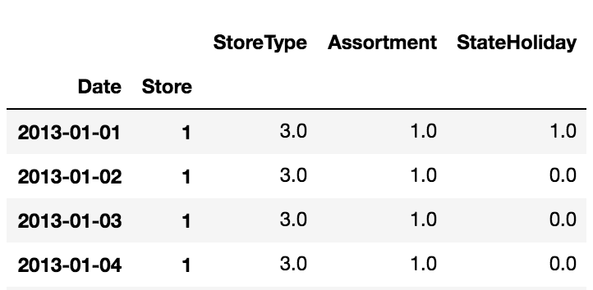

I split date information into several aspects to let the model learn time series data. They are DayOfWeek, DayOfMonth, WeekOfYear, DayOfYear, Month, Year and Season.

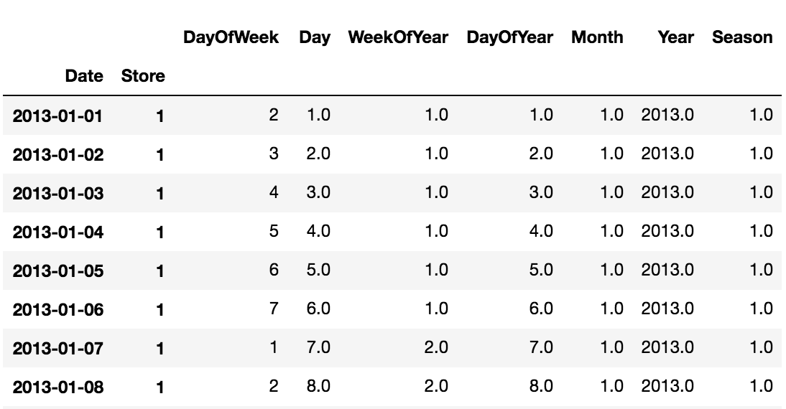

Then I start two new features about competition during and promotion duration from Competition start date and Promo2 start date.

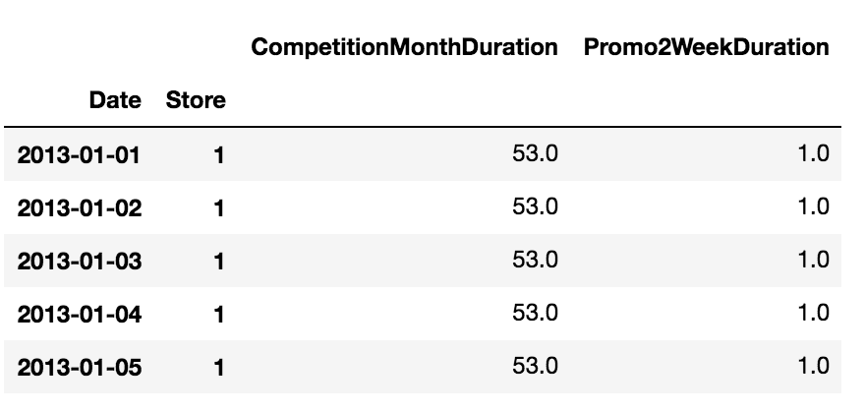

For training data and evaluation data splitting, I will split out the training, test set in a way of time series. I will use last 2 weeks for testing data for evaluating the model as it’s good at practice.

**Implementation**

By finishing data preparation, I start to build up the XGBoost model for training the dataset.

Starting by setting the model as a little bit high learning rate and less trees for verification. Since from those parameters setting, I can find out which features are useful in descending the evaluation loss rate. I will use this pre training to find out the useful features for deep study.

The initial parameters I set is like this: eta: 0.4, max_depth: 8, subsample: 0.8, colsample_bytree: 0.9, min_child_wight: 8 and seed: 31.

I will add the watchlist inside the XGBoost trainer to monitor the evaluation progress, and add early stopping as 100 to stop training if no more better descending. At first I used 300 estimators for test training.

The evaluation score is 0.1215 at training dataset. After uploading to the Kaggle Data Board, the public score is 0.12674 and private score is 0.14387, either of them are lower than 0.117. Meaning that the train, test dataset are actually good to simulate the online test dataset. However, the model is overffiting to the dataset, making the private score is worse.

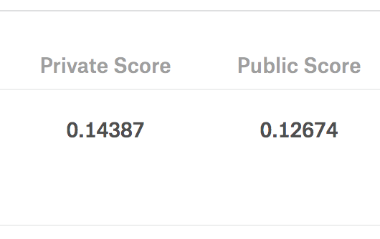

From the training model, we also generated two diagrams for reviewing as below.

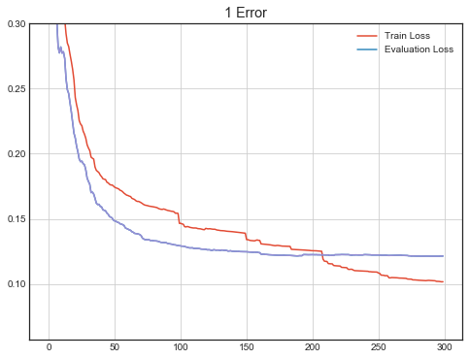

The above diagram shows that the evaluation loss has not been dramatically decrease since 150 estimators, and even worse, it’s going up, meaning the model is overfitting.

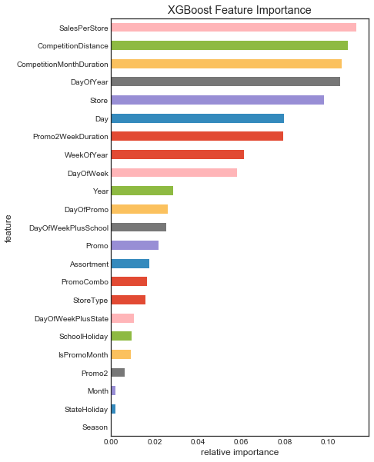

The above features importance diagram shows the importance of each feature during the model building.

From the above diagram, I interpret that XGBoost is better when the features are categorical spread. Some of the features are close, we need to combine them for efficiency.

**Refinement**

Several refinements strategies I used:

1. Feature Engineering:

I drop some similar features and remain features as CompetitionDistance, DayOfWeek, Open, Promo, Store, WeekOfYear, DayOfYear, Day, Month, Year, CompetitionMonthDuration, Promo2WeekDuration. Some new features I added:

**SalesPerStore** : History Sales data divide by History Customer data, average for each store.

**State [14]:** New Feature from external resource, the state each store belongs to.

**AssortStore:** Combine Assortment and StoreType, generate a new feature with Label coding

**DayOfWeekPlusState**: Combine DayOfWeek and StateHoliday to generate a new feature

**DayOfWeekPlusSchool**: Combine DayOfWeek and SchoolHoliday to generate a new feature

**DayOfPromo**: Combine Day and Promo to generate a new feature

**PromoCombo**: Combine Promo and Promo2 to generate a new feature

**Reference**

1. Time series <https://en.wikipedia.org/wiki/Time_series>
2. Regression Analysis <https://en.wikipedia.org/wiki/Regression_analysis>
3. Supervised Learning <https://en.wikipedia.org/wiki/Regression_analysis>
4. Linear regression http://scikit-learn.org/stable/modules/linear_model.html
5. SVM <http://scikit-learn.org/stable/modules/svm.html>
6. Decision Tree <http://scikit-learn.org/stable/modules/tree.html>
7. Mean absolute error <https://en.wikipedia.org/wiki/Mean_absolute_error>
8. Mean squared error <https://en.wikipedia.org/wiki/Mean_squared_error>
9. Coefficient of determination <https://en.wikipedia.org/wiki/Coefficient_of_determination>
10. Root Mean Square Percentage Error <https://www.kaggle.com/c/rossmann-store-sales#evaluation>
11. Stochastic gradient descent <https://en.wikipedia.org/wiki/Stochastic_gradient_descent>
12. XGBoost Tutorial <https://xgboost.readthedocs.io/en/latest/model.html>
13. Complete Guide to Parameter Tuning XGBoost <https://www.analyticsvidhya.com/blog/2016/03/complete-guide-parameter-tuning-xgboost-with-codes-python/>
14. State csv https://github.com/entron/entity-embedding-rossmann